Application architecture:

Monolithic:

Benefits:

* Simple to develop, deploy and test

Challenges:

* Hard to scale, complex, redeploy the entire app on each update

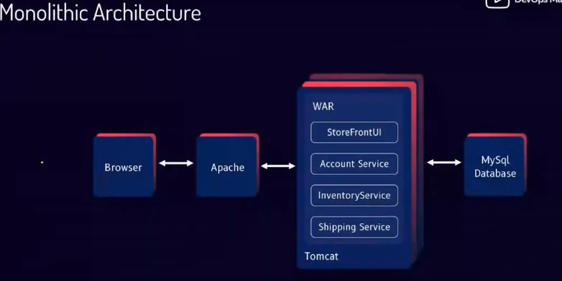

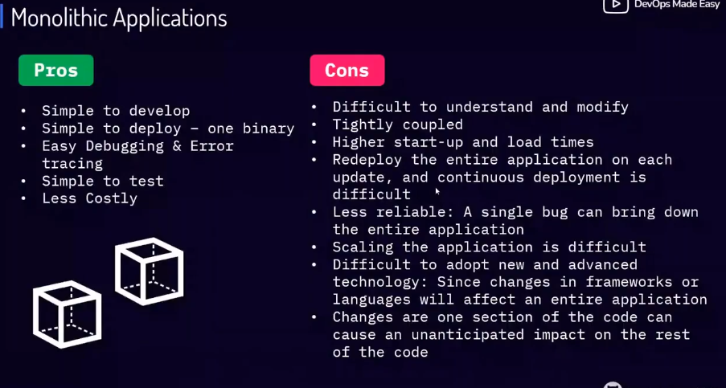

Microservices:

Benefits:

* Better scaling, frequent releases

Challenges

* Slower deployment, Complex configuration, load balancing

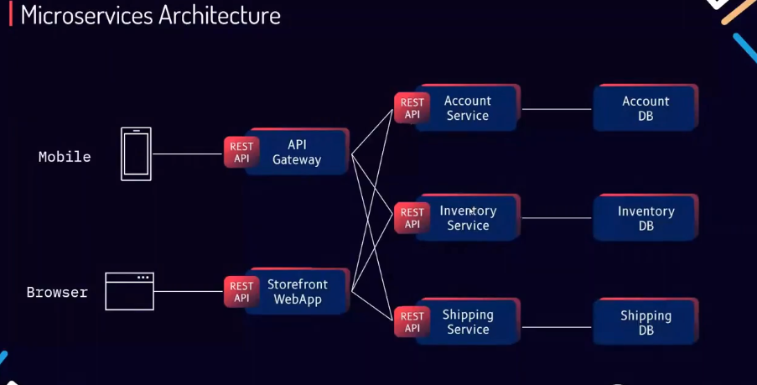

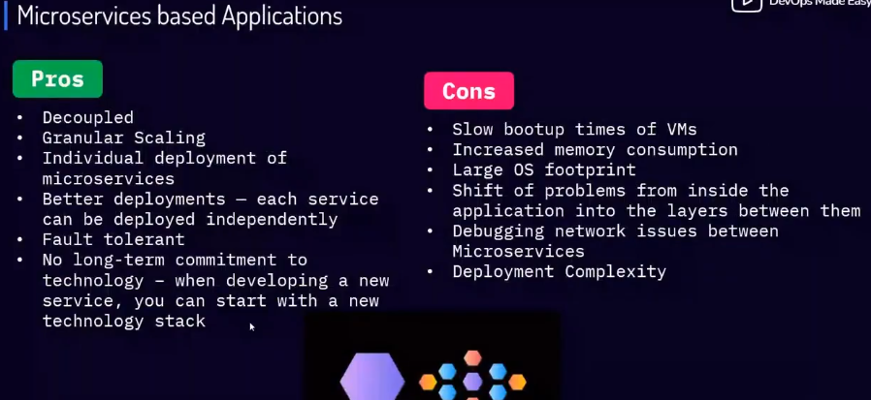

Docker:

Benefits:

* Faster deployment, leithweight images

Challenges:

* No storage options, no autoscaling, networking is complex

Kubernetes:

Benefits:

* Storage, autoscaling, self healing

Challenges:

* Hard to install, No build in Jenkins

Virtual Machine:

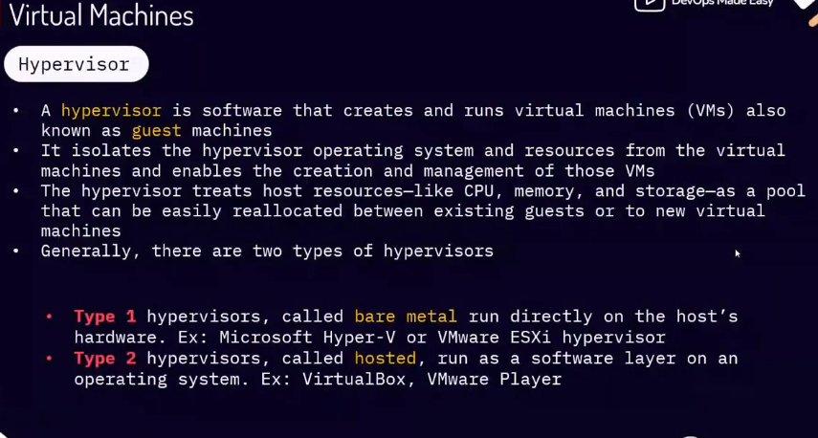

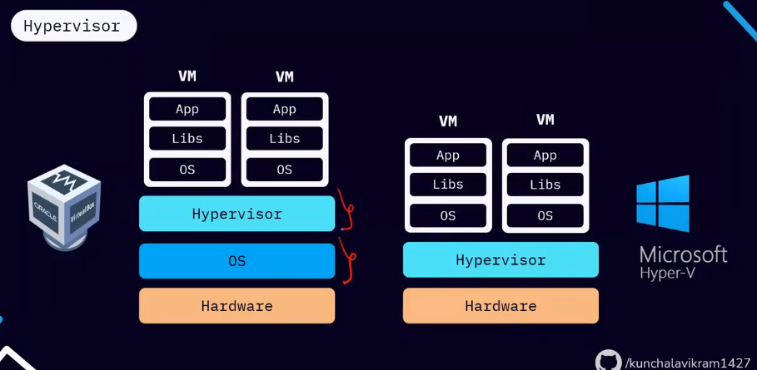

**Docker:**

Docker is a software development tool and virtualization technology that makes it easy to develop, deploy and manage applications using containers

It uses OS/Kernel virtualization

**Architecture:**

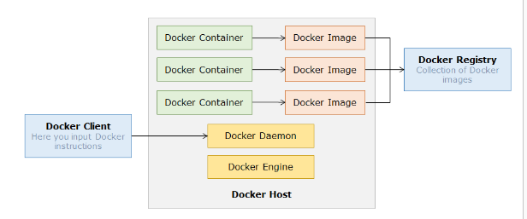

Docker follows client-server architecture:

Docker Client: It takes input/commands from user and gets the response from daemon

Docker Daemon: It builds, runs, and ships containers and can exist on same or different hosts

Docker Engine: It is a packaging tool which provides workflow for building and containerizing your application

Docker Hub: It hosts a registry to upload and manage your apps

Docker Images: It is a read-only template to create containers

Docker Registry: It holds images in public or private store

Docker Container: It holds applications along with dependencies

* Docker is based on Linux Containers (LXC) which replies on two kernel mechanism : Control groups and Namespaces
* Docker provides isolated workspace for all its containers through Namespaces (It provides a container with its own linux system)
* CGroups allocates and limits resources such as CPU, memory. They restrict the container processes from too much utilization of Host machine’s resources

To run docker commands, you have to be a root user else, add yourself to dockergroup

Usermod -aG docker <yourname>

Reload the docker daemon

Systemctl restart docker

Newgrp docker

Docker Images: A package which consists of an application binaries with all its dependencies and configuration files needed to run the code.

Docker image can have series of layers, each layer represents an instruction that we run

Check docker status

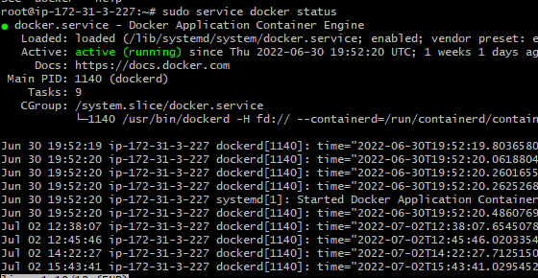

Docker root directory: /var/lib/docker

We can change the docker root directory to any NFS (network file system) i.e. any server where we create a mount point and then attach that mount point

Docker commands:

Docker [management_command] [sub_command]

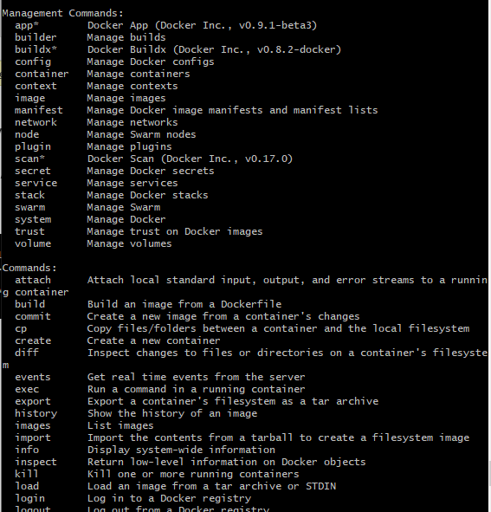

Why docker images are used:

* Customization of environment
* Allows rapid development cycle
* Easy modification and efficient versioning

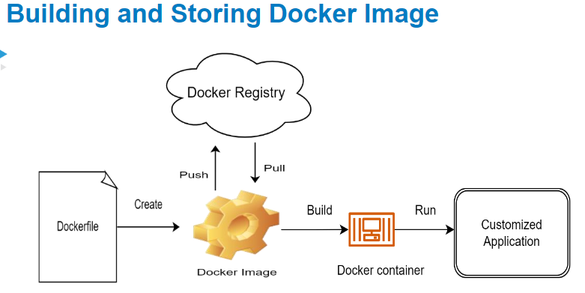

|  |  |
| --- | --- |
| Commands | Description |
| Docker info | Details about docker installed |
| Sudo service docker status | Current running status of docker |
| Ps aux | List down all running processes |
| Docker system df | Know about the images volumes, build cache |

**Lifecycle of docker images:**

1. Login to docker hub account, use command docker login

$ docker login

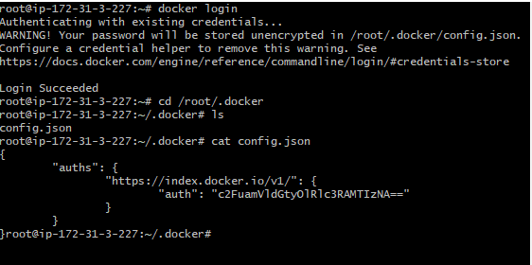

Credentials are stored in /root/.docker/config.json

1. Image pull from docker hub and check image

$ docker pull <imageName>:tag

$ docker images

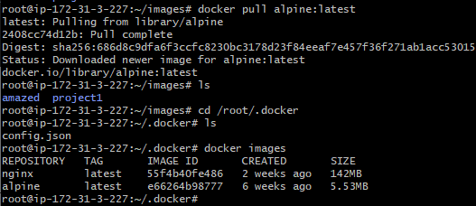

1. Tagging an image

$ docker tag <imageName:tag> <newname:tag>

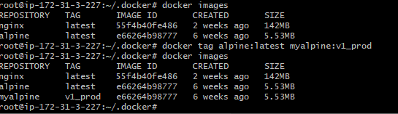

1. Untag the image / remove image

$ docker rmi <image:tag>

***Customize docker images using containers:***

Step_1: Launch a container from existing image

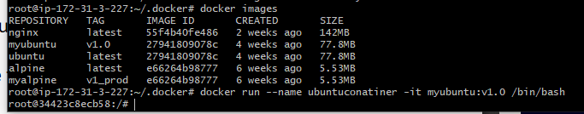

Step_2: Install packages or make changes as needed

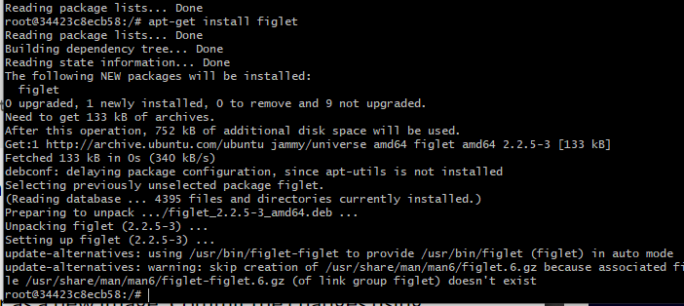

Step_3: Exit the container and commit



docker commit [OPTIONS] CONTAINER [REPOSITORY[:TAG]]

Step_4: Launch new container using custom image

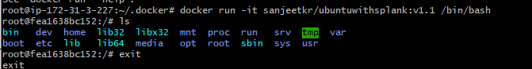

|  |  |
| --- | --- |
| Commands- Images | Description |
| Docker image pull <imageName>:tag | Get image from docker hub |
| Docker image -ls | Check image details |
| Docker inspect ImageName:tag | Get complete info about an image |
| Docker image rmi imageName:tag | Remove image |
| Docker tag imagename:tag <newname> | Renaming an existing image |
| Docker image push imagename:tag | Push image |
|  |  |

dockerhub: newname= username/imagename

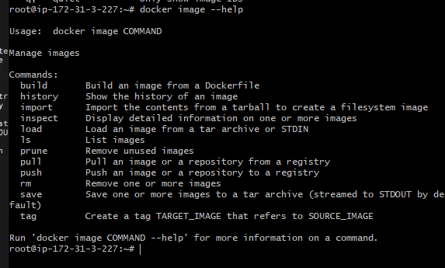

Login to dockerhub:

Docker login credentials are only first time, it will be stored in $HOME/.docker/config.json as auths

Credentials are encoded as base64 utility

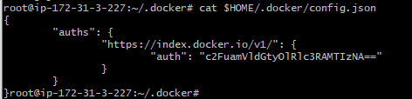

Encoding

Echo credrntials | base64

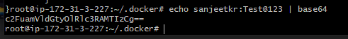

Decoding

Echo ‘encodedstring’ | base64 -d

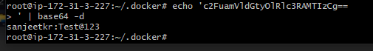

Containers:

There are two types of containers:

1. Interactive containers: terminal access i.e. run commands inside container and get output
2. Daemonized containers: run in background processes

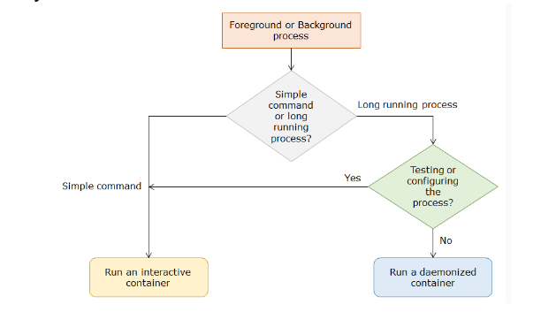

When running a container, container might run in foreground i.e. using the same terminal so you cant do anything, you will have to come out of it Ctrl +c, but this will stop the container

**Docker container run –name <name> -d -it -p imagename:tag**

-d : detach mode

--name: name the container

--i : to make an interactive connection using standard input (STDIN) in container

--t : to assign a pseudo terminal/TTY inside the container that attaches stdin and stdout.

--rm=false : to automatically remove the container when it exits. Usually, we use --rm flag for commands that run-inforeground, to clean up the container after the command has completed

Running a container in background: using detach flag

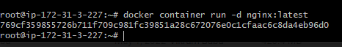

Renaming a container: using --name

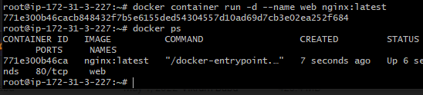

Running a command inside the container: use exec command

Docker exec conatinerID <command>

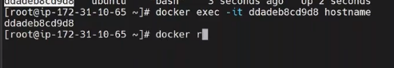

To start a new process inside an already running container,

Docker exec -d container mkdir/tmp/test

To get terminal access use -it

docker exec -it my_daemonized /bin/bash

To disconnect temporarily from the container without terminating it **Ctrl+p+q**

|  |  |
| --- | --- |
| Commands - Container | Description |
| Docker container run imageName:tag |  |
| Docker container rm containerID |  |
| Docker container start / stop / restart |  |
| Docker logs containername  To see runtime logs, use flag -f i.e. follow |  |
| Docker stats conatinerid | Get container resource usage |
| Docker container top containerid | Display the running processes of container |
| Docker ps | List of running containers |
| Docker ps -a | List of all stopped containers |
| Ps aux | List process running in container |
| Docker inspect container | Information about the container |

To make the container accessible from other networks, we use port mapping

Docker container run –name web -d -p HOST_PORT:CONTAINER_PORT imageName

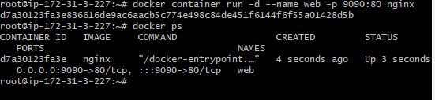

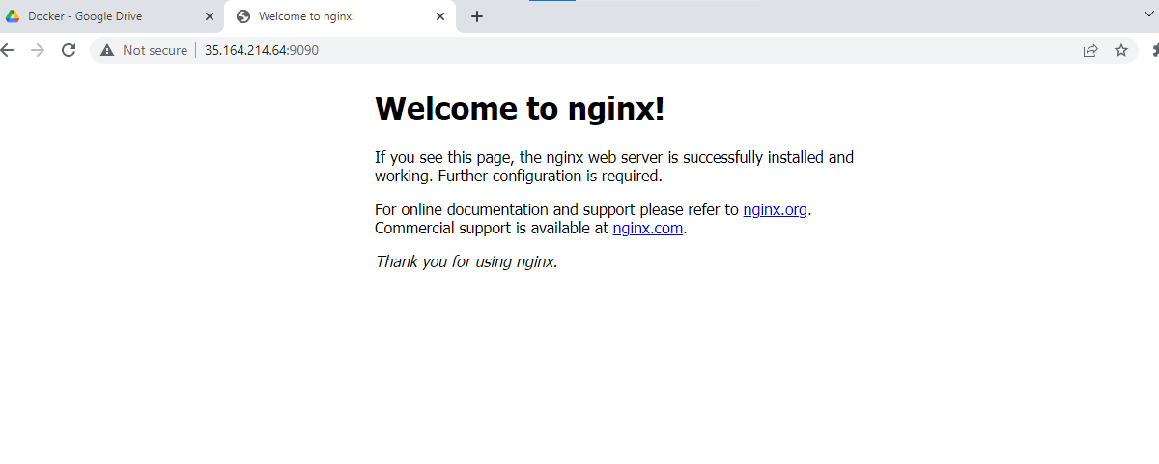

We can expose multiple ports

Docker container run –name web -d -p HOST_PORT:CONTAINER_PORT -p HOST_PORT:CONTAINER_PORT -p …. imageName

For http standard port is 80

For https standard port is 443

Restart policy:

To configure the restart policy for a container, use the --restart flag when using the docker run command. The value of the --restart flag can be any of the following:

| **Flag** | **Description** |
| --- | --- |
| no | Do not automatically restart the container. (the default) |
| on-failure[:max-retries] | Restart the container if it exits due to an error, which manifests as a non-zero exit code. Optionally, limit the number of times the Docker daemon attempts to restart the container using the :max-retries option. |
| always | Always restart the container if it stops. If it is manually stopped, it is restarted only when Docker daemon restarts or the container itself is manually restarted. (See the second bullet listed in [restart policy details](https://docs.docker.com/config/containers/start-containers-automatically/#restart-policy-details)) |
| unless-stopped | Similar to always, except that when the container is stopped (manually or otherwise), it is not restarted even after Docker daemon restarts. |

Added new things in running container, now take snapshot and save it as a new image

Using commit

Docker commit conatinerid <imageName>

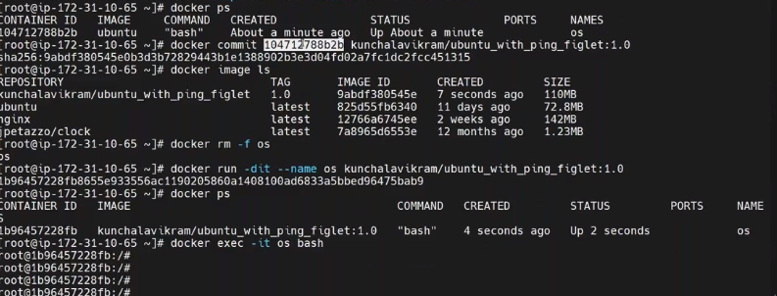

**Share images with others:**

share and load

Docker image save imageName:tag > newname.tar, using redirect

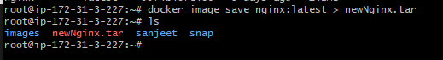

Now, when you have some image.tar, we can load it

Docker image load < image.tar

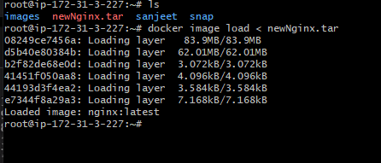

# **Docker File**

* It is a set of instruction to build own docker images
* It is a file without any extension
* It consists of
  + Base image on top of which we build our image
  + A set of tools and application to be installed in the new image
  + A set of files to be copied into the docker image ( config, app files)
  + Environment variables etc.
* File content:

|  |  |
| --- | --- |
| **Keyword** | **Description** |
| FROM | Defines the base image used to start the build process; this is the first instruction in docker file but ARG can also be used as first instruction    OR |
| MAINTAINER / LABEL | Defines name and email of image creator; mention author’s name i.e. it adds metadata to image. It is a key-value pair, to include spaces within label values use quotesand backslash (\) for multiplines  It is deprecated , now its called as LABEL    To view image’s labels , use docker inspect |
| COPY | Copies files from host to image; |
| ADD | This command also copies one or more files/directories from the docker host into image  It can also extract TAR files from the docker host into docker image and download files from a URL and copy them into the docker image  It eliminates the need for untar and download utilities like wget and curl |
| RUN | Runs command while image is being built and saves output as new layer;  They can be used to install utilities, application, extract files  Every run instruction will create a new layer on top of current image and commit  It has two forms: shell form and exec form  Shell form: the command is run in shell    Exec form: runs binaries      Multiple run commands can be clubbed together using && |
| ARG | To supply arguments while building image; aka build-time variables;  If docker file expects ARG variables but none is provided docker will throw error, to avoid that always give default values  ARG values can be inspected after image built by using docker history of that image  It’s value is passed in build command as |
| ENV | To supply environment variables to the image; aka runtime variables  ARG is compile time variable, ENV is runtime variable  ENV values can be overridden when starting a container using -e flag or –env |
| EXPOSE | Exposes a specific port to enable networking between container and outside world;  It is just for documentation to convey the port to be used by the person who runs container, it doesnot actually publish any port    To actually publish port, we use -p flag on docker run |
| VOLUME | Used to enable access from the container to directory on host;  This instruction creates a directory inside the docker image which can later mount a volume to from host |
| WORKDIR | Used to set default working directory for the container. Similar to cd in the container  If the directory specified doesn’t exist, it will be created and cd to it |
| CMD | Command that runs when container starts; used to give default command to be run when starting the container not during image build like RUN  There can be only one CMD instruction per docker file, if you give more than one then only the last CMD will work  We can check the default CMD of an image using docker inspect          Express command as a JSON array and give full path to the executable |
| ENTRYPOINT | Commands that run when container starts;  It works similar to CMD |

$ docker build -f DockerFileName -t imageName .

. represents current directory

* The docker build command builds image from a docker file using a context ( it is a set of files/directories at a specified location PATH)
* Build process send the entire context (current working directory contents) recursively to the daemon as Tarball
* It is good practice to start with an empty directory as context
* To increase build’s performance, exclude files and directories by adding a .dockerignore file to the context directory

When to use CMD:

* Specifying default programs that should run when users do not input arguments in the command line
* This instruction ensures the container is in a running state by starting an application as soon as the container image is run

When to use entrypoint:

* Used for scenarios where you want the container to behave exclusively as if it were the executable it’s wrapping
* When you don’t want or expect the user to override the executable you’ve specified

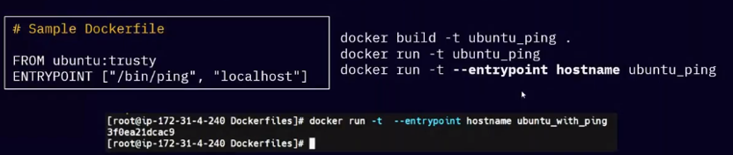

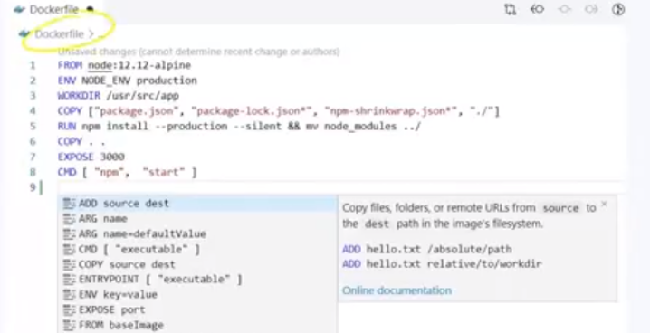

Remove all images in one go:

$ docker rm -f $(docker ps -a -q)

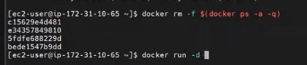

Docker Registry:

Docker Registry is a service that **stores** your docker images, but it could be hosted by a third party and even private if you need so

Docker Repository:

A Docker Repository is a **collection** of related images with same name, that have different tags. Tags are an alphanumeric identifier attached to images within a repository

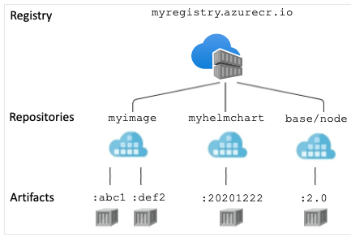

**Pull and Push in local registry**

To make a local registry:

$ docker run -d -p 5000:5000 –restart=always –name registry registry:2

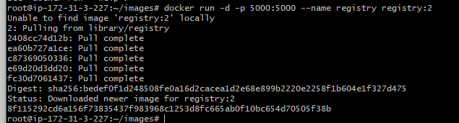

Pull image to local registry:

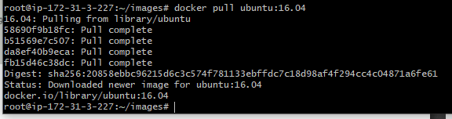

Tag the image:

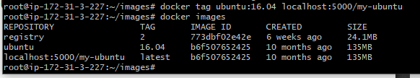

Push the image to local registry

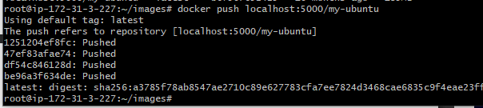

Remove the images from local

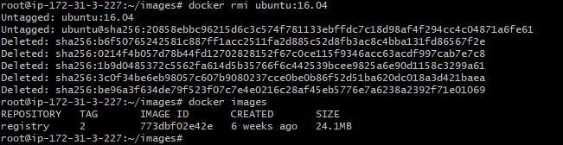

Now pull it from local registry

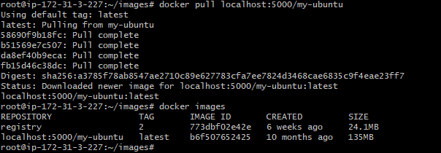

# Docker volumes:

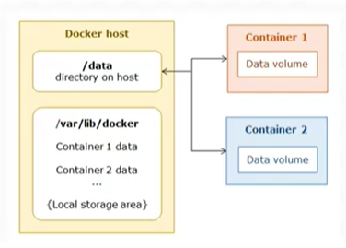

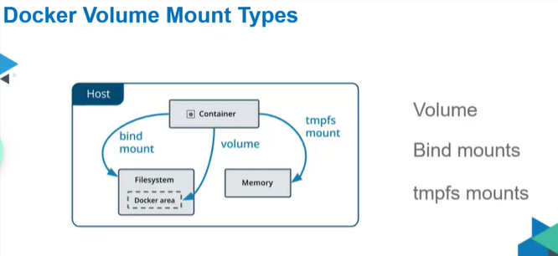

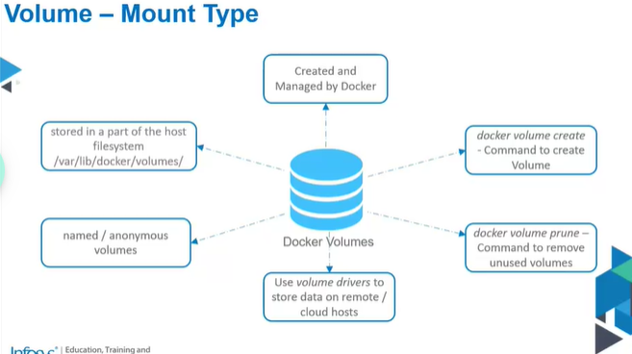

Volume:

* Default volume location: /var/lib/docker/volumes/
* Syntax

-v vol_name:container_directory

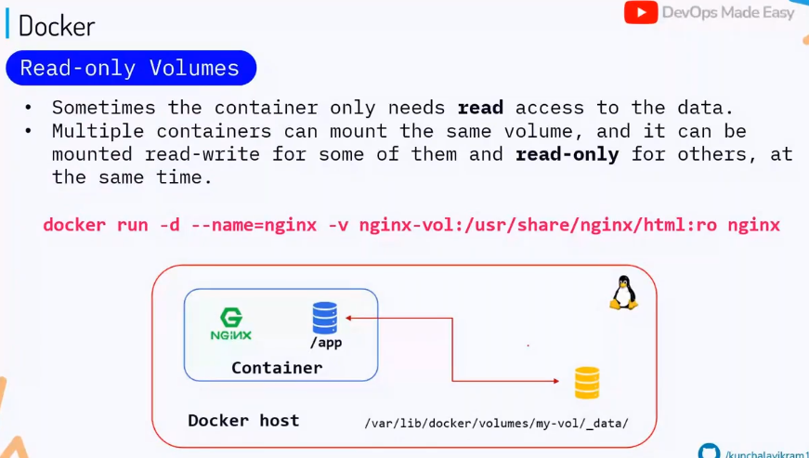

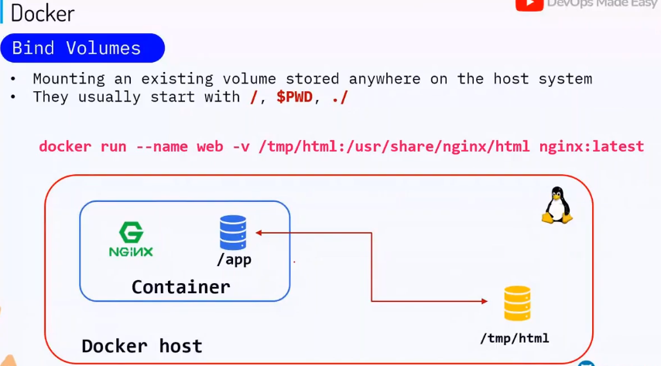

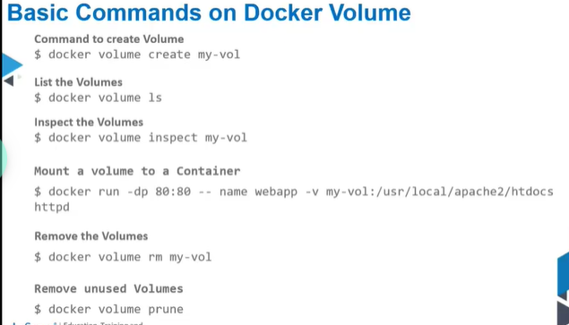

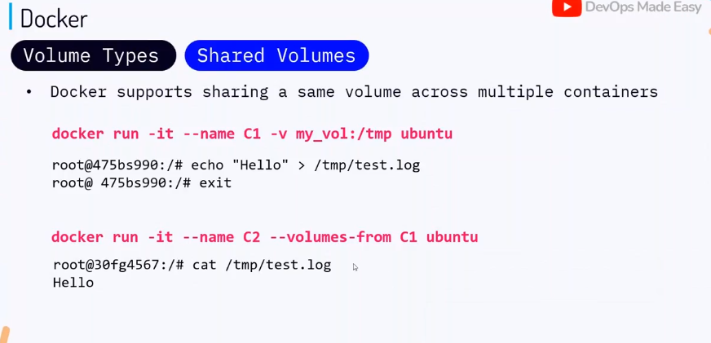

Remove all containers at one go



Create a volume:

$ docker volume create <vol_name>

Inspect volumes:

$ docker volume inspect <vol_name>

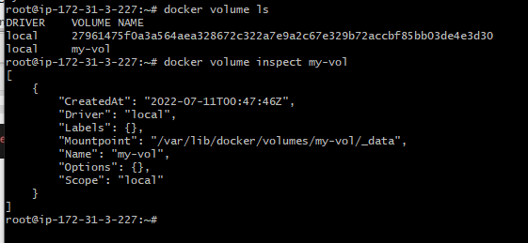

Make changes in volume file:

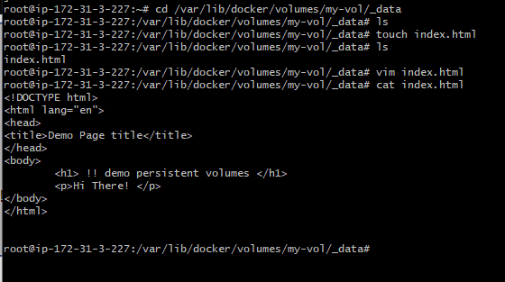

Launch apache container on port 80

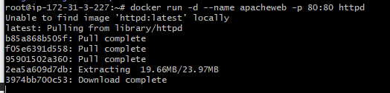

Check the container running httpd



Now stop the same container and mount the volume

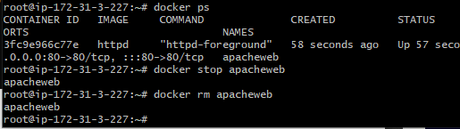

docker run -d --name apachevol -p 80:80 -v my-vol:/usr/local/apache2/htdocs httpd

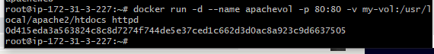

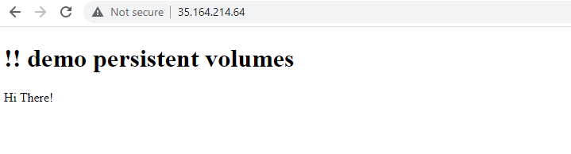

Remove volume

$ docker volume rm <vol_name>

Delete unused volume

$ docker volume prune

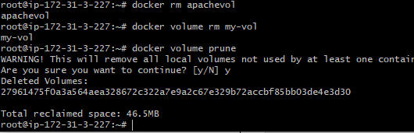

# Exercise : Map a data volume to a ubuntu conatiner

1. Launch an ubuntu container and map a folder on the host to its volume.

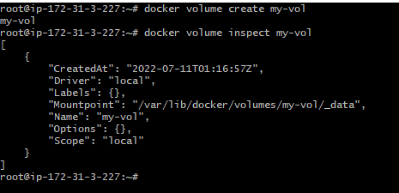

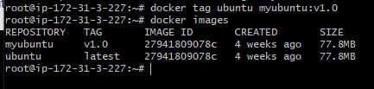

/usr/local/sbin:

1. Ensure that the data volume is mounted in read-only mode (:ro). Hence files accessible within the container shouldn't be editable.

docker run -d --name ubuntuConatiner -it -v my-vol:/usr/local:ro myubuntu:v1.0

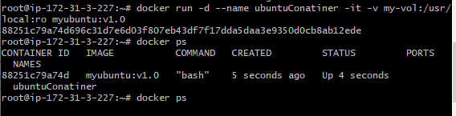

1. Verify that the data is properly synchronized.



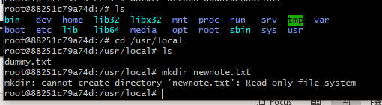

# **Docker networks:**

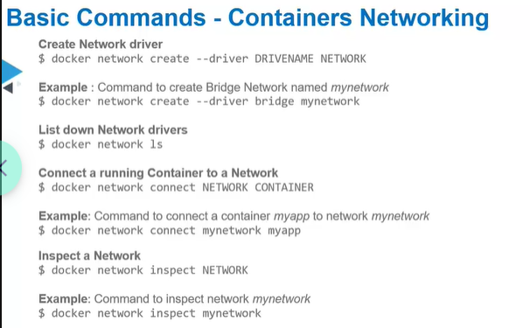

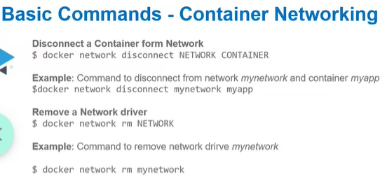

Environment Variables: Variable whose value is set outside the program like API URI, Domain name etc

Environment variables are passed as key-value pair

You can view env variables through docker container inspect

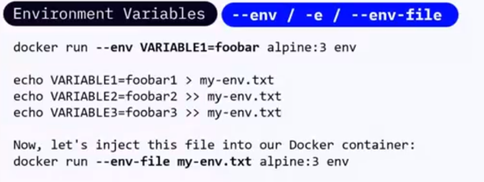

$ ss -ltup

Find listening port

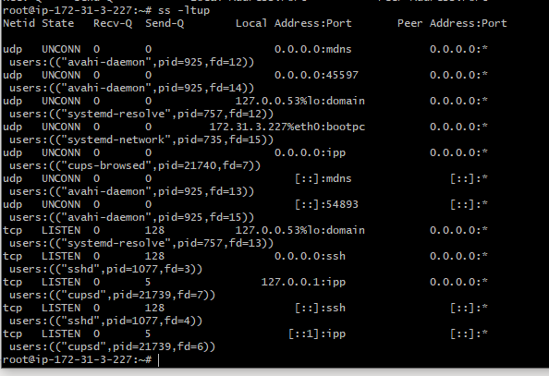

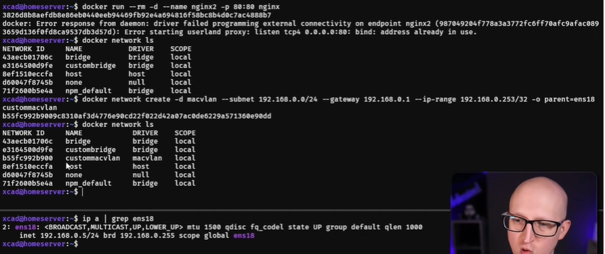

Macvlan/ipvlan: IF port is already assigned by host, but u want to use the same port to run container on host. Create network driver of macvlan and bind it to physical network of host

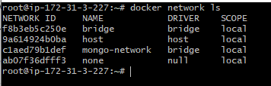

Bridge network: A network bridge joins two separate computer networks

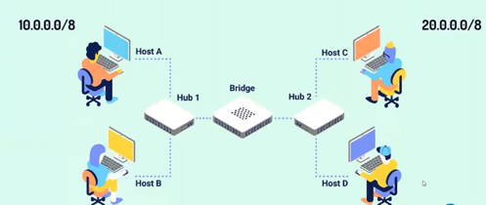

* Brctl command is used to create bridges, add/remove interfaces and view bridging table
* Bridge networking apply to containers running on same host machine. For communication among container running on different docker hosts, you can either manage routing at OS level or you can use Overlay networking
* When we start docker, a default bridge network interface (**docker0**) is auto created and newly created containers are attached automatically unless otherwise specified
* Run ifconfig on linux host to view the bridge network

DNS resolver:

* Docker has in-built DNS resolver 127.0.0.11
* DNS resolver is also known as Nameserver , it resides in /etc/resolve.conf
* There is no DNS resolver for default bridge network

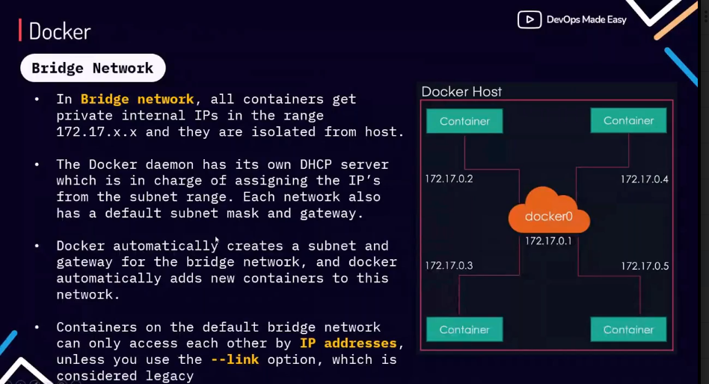

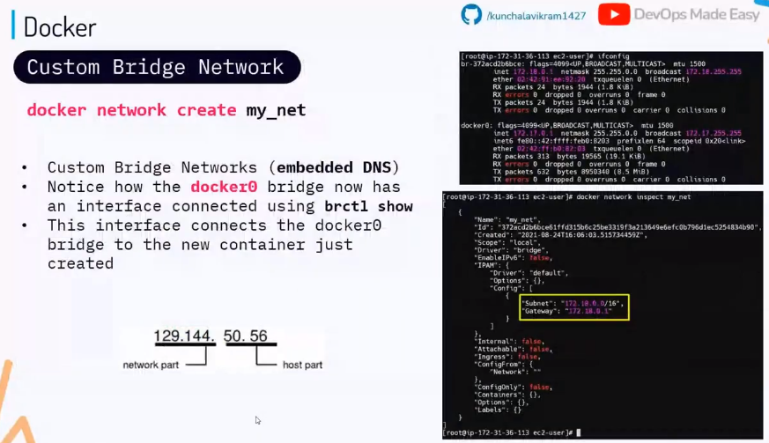

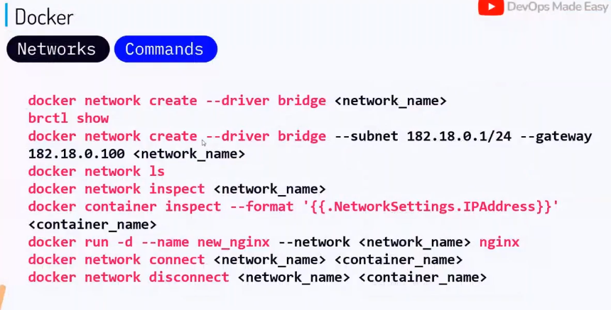

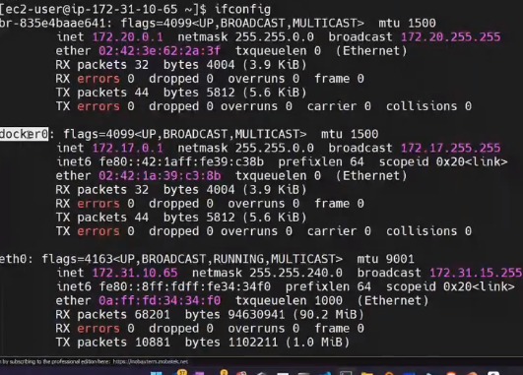

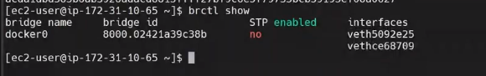

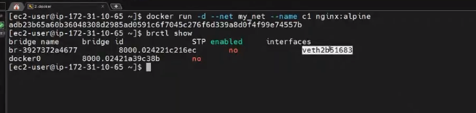

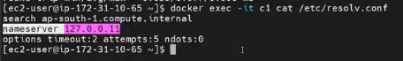

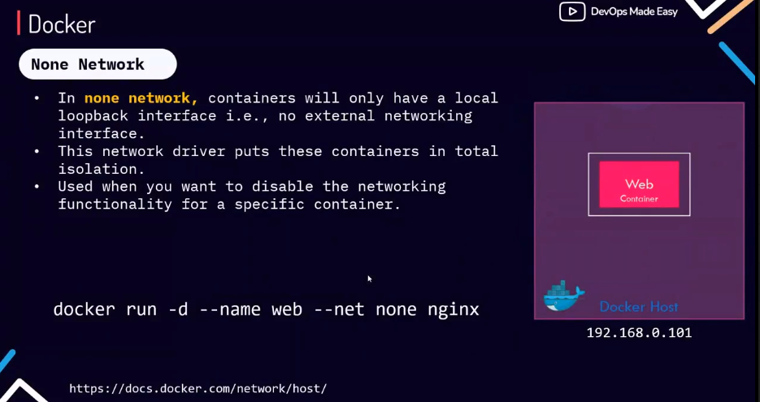

Isolated networking:

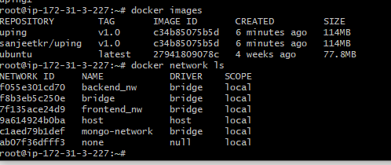

2 containers in frontend_nw and 2 in backend_nw

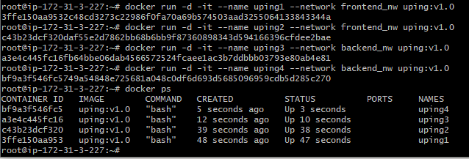

Brctl show

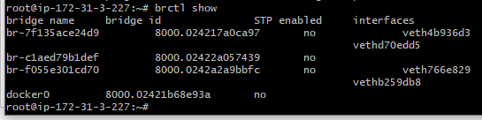

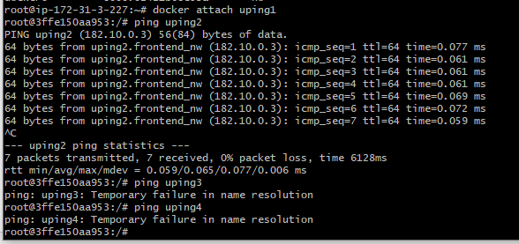

Since container 1 and 2 are in same subnet, they can communicate but container 3 &4 are unreachable bcz they are in different subnet

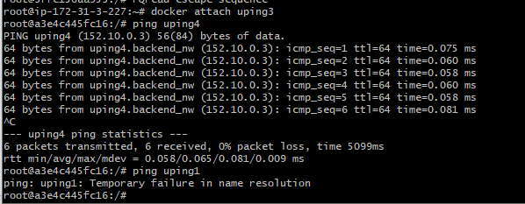

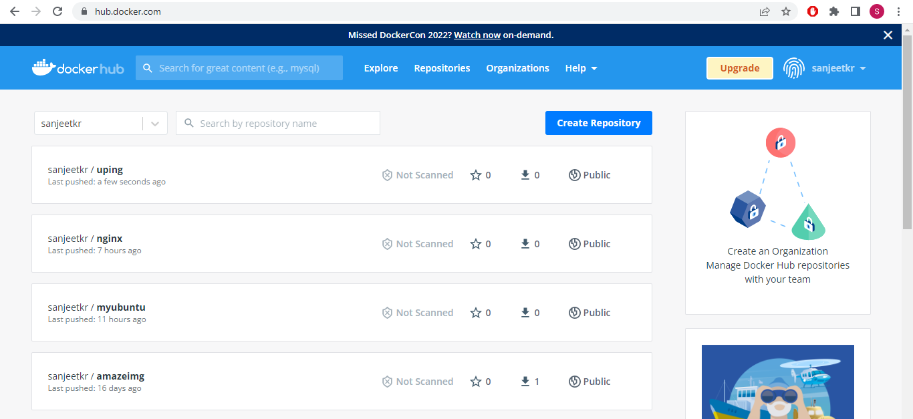

<https://github.com/docker/awesome-compose>

# **Load balancing in Docker:**

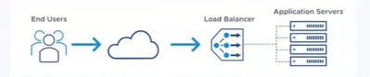

Load balancer uses:

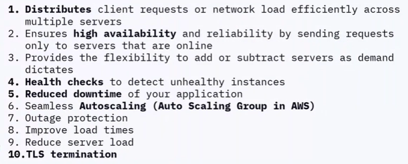

Load balancing algorithm:

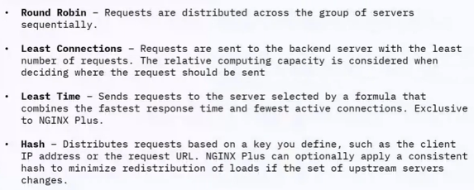

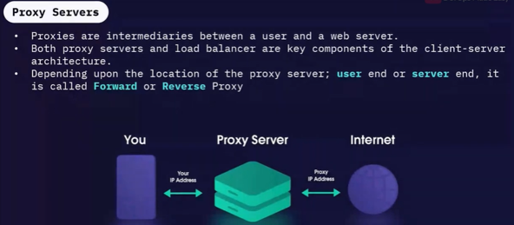

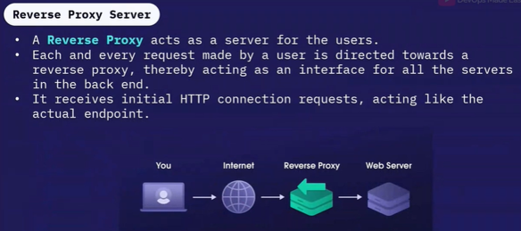

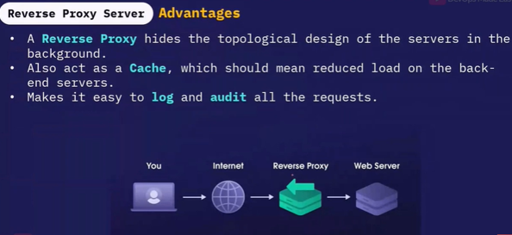

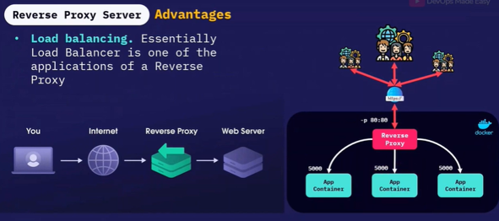

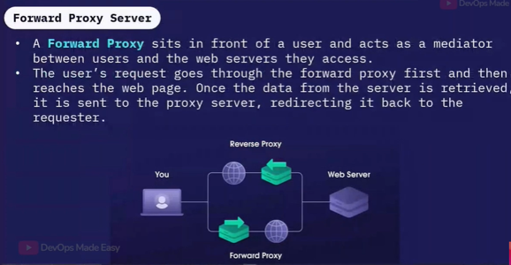

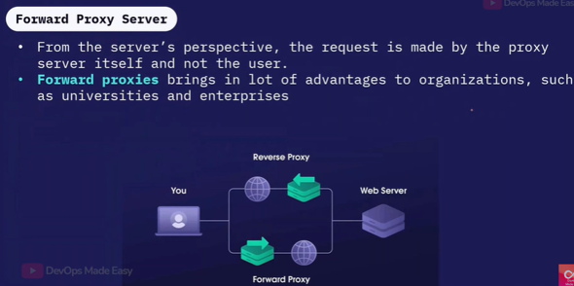

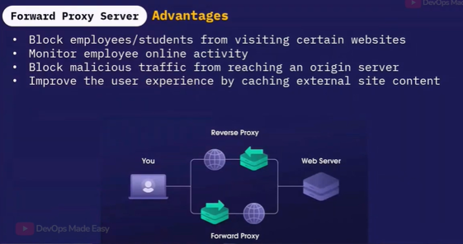

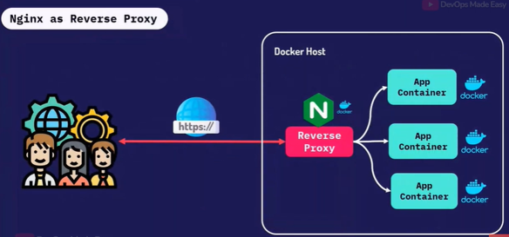

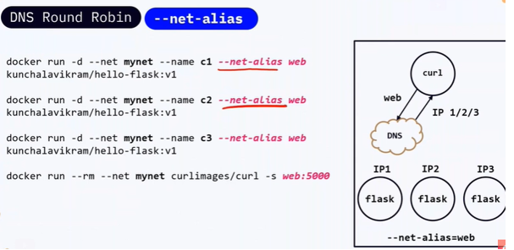

Multistage

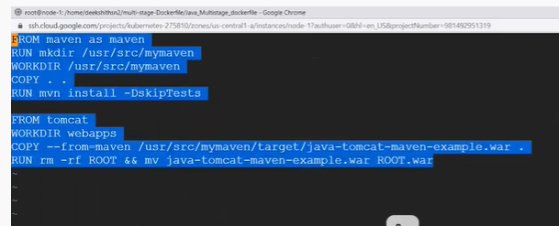

<https://github.com/DeekshithSN/Java_Multistage_dockerfile.git>

# **Docker Compose:**

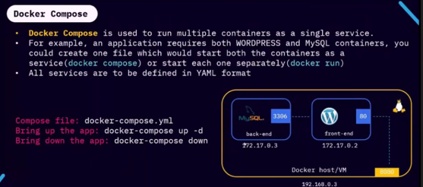

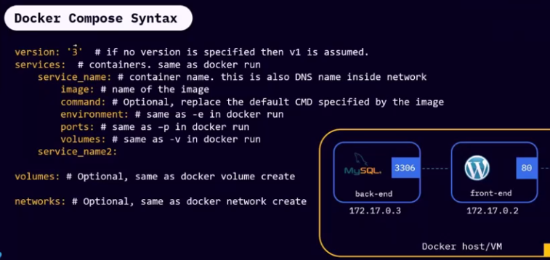

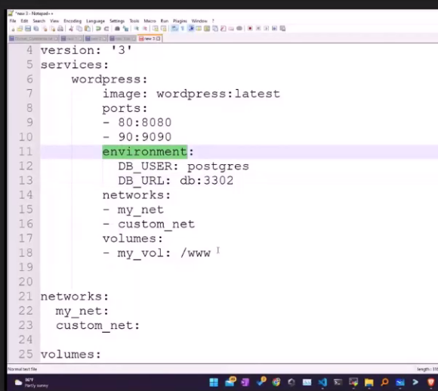

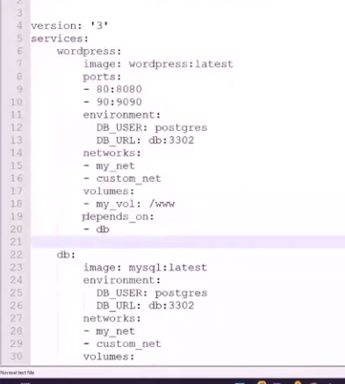

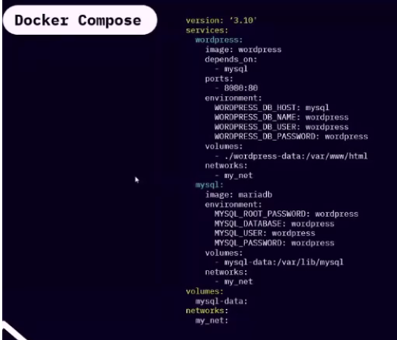

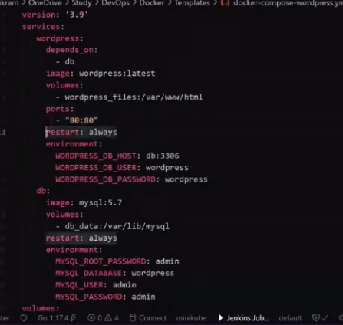

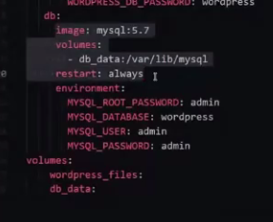

On this page you build a simple Python web application running on Docker Compose. The application uses the Flask framework and maintains a hit counter in Redis

* Build an image starting with the Python 3.7 image.
* Set the working directory to /code.
* Set environment variables used by the flask command.
* Install gcc and other dependencies
* Copy requirements.txt and install the Python dependencies.
* Add metadata to the image to describe that the container is listening on port 5000
* Copy the current directory . in the project to the workdir . in the image.
* Set the default command for the container to flask run.

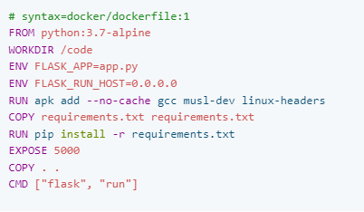

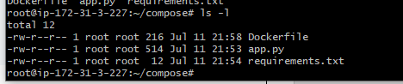

The web service uses an image that’s built from the Dockerfile in the current directory. It then binds the container and the host machine to the exposed port, 8000. This example service uses the default port for the Flask web server, 5000.

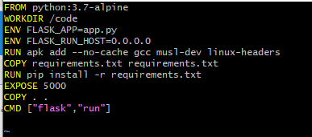

Mini-project- Emart

Client

Angular

/

API Gateway

NGINX

/webapi

/api

DB

MySQL

DB

Mongo

Books API

JAVA

Emart API

NodeJS

